Daniel Sung

Design Documentation

4.3.23

Site Map:

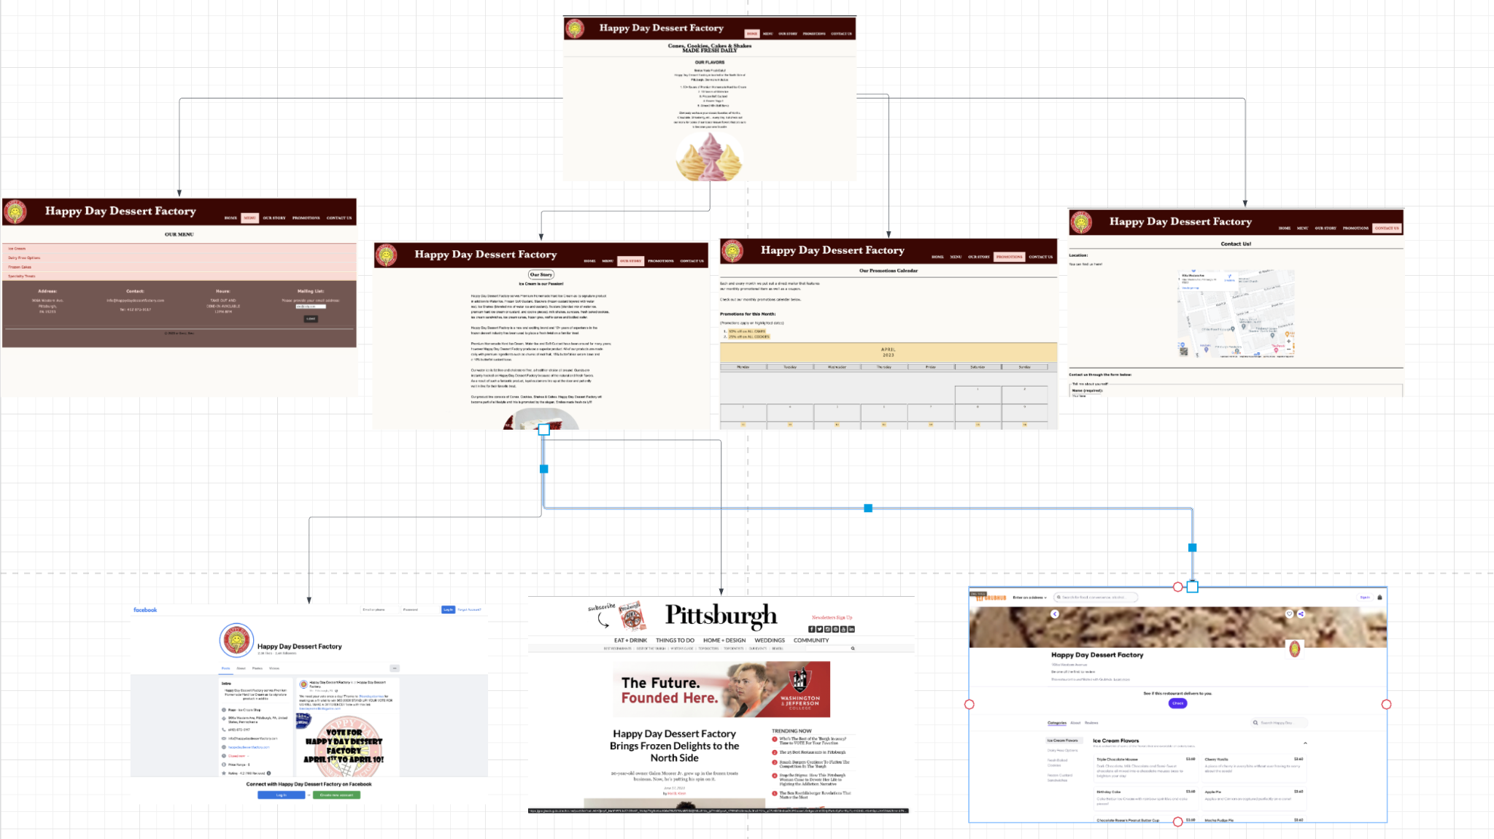

Information Architecture

* My main goal for the website was to create a user-friendly experience for users that allows them to navigate through information intuitively. For example, I divided up the website into five main categories: home, menu, our story, promotions, and contact us. This allows users to clearly navigate through the various options given depending on what they are looking for. For example, all of the options for desserts would be located in the menu section. If the user wishes to learn more about the story of Happy Day Dessert Factory, they would click on the Our Story section for more information. Furthermore, if they have any requests or complaints they would simply be able to click on the Contact Us page which would lead them to the contact form. This intuitive information architecture would attract customers to return as the information they sought was easily accessible. In addition, the mailing list subscription would help retain customers that sign up for the list as they receive new updates of promotions or special products.

Wireframing to Development

* The final product of the wireframing process was almost replicated in the development of the website. The color scheme and fonts were maintained throughout the development of the website. The homepage wireframe was changed up a little bit in terms of formatting because of the addition of the javascript libraries. The menu section was identical in terms of the design and the placement of the various options available for customers. The Contact Us and Our Story pages both had revamps of the original structure planned in the wireframing process. For example, on the Contact Us page, the contact form section included much more questions and information to be collected from the users. Overall, the wireframing was the primary guidance throughout the development process with minor changes along the way in terms of formatting and additional information.

Javascript Libraries used

* jQuery: Accordion: <https://jqueryui.com/accordion/>
* AOS (animation on scroll) animation JS: <https://michalsnik.github.io/aos/>
  + Animation effects: fade-right, fade-left, fade-up, etc for Homepage.